DESCRIPTION OF AN INDIVIDUAL BASED FISHERIES SIMULATION OPERATING MODEL (IBM)

**______________________________________________**

*Jeremy McKenzie*

*Nokome Bentley*

*Richard Bian*

04-04-2016 Ver 1.1

1. What is an IBM? 3

2. IBM Specifications 4

2.1. Core dynamics 4

2.2. Spatio-temporal structural definitions 5

2.2.1. Order individual fish processes occur within a time step 5

2.3. IBM run phases 6

2.4. Model population dynamics 6

2.4.1. Spatial and temporal structure 6

2.4.2. Recruitment 6

2.4.3. Growth 7

2.4.4. Natural mortality 7

2.4.5. Maturity and sex processes 7

2.4.6. Movement 7

2.4.7. Gear selectivity 8

2.4.8. Catch removals (harvest) and tag recovery 9

2.4.9. Tag release 9

2.5. Individual fish attributes 9

2.6. Within time-step model processes 10

2.7. Model speed and parallelisation potential 11

2.8. Model individual scaling 11

3. IBM tests and validation results 12

3.1. Individual growth path model validation 12

4. References 13

5. APPENDICES 13

# What is an IBM?

This document provides a technical description of an Individual Based Model (IBM) software tool for building fish stock catch history models. The main use of this model is for evaluating the performance of age or length-based stock assessment models and for building “real-world” construct models for use in Management Strategy Evaluation (MSE).

The IBM modelling tool described in this document was specifically built to be the operating model component of Management Strategy Evaluation for the Northern New Zealand snapper stocks (SNA 1 & SNA 8). It is capable of simulating the complex spatial and mixing dynamics evident in these stocks and for generating observational data required by the current assessment models, specifically: mark-recapture (tagging); commercial catch at-age and length, CPUE indices, and recreational harvest estimates. Although capable of complex configurations simple parameterisations are also supported. We believe the base IBM software has a wide range of management applications beyond MSE, for example the exploration of optimum yield, i.e. yield per recruit (YPR), or testing stock assessment model performance. The base model c++ code resides in the public domain and can be downloaded from the following repository: https://github.com/trophia/sna1 .

The main advantage of IBMs is they a free for formal partition space limitations of more standard models. Partitions such as length, age, spatial location, growth dynamics, tag status, are all defined as attributes of the individual fish. The frequency of fish in the IBM for any point and any desired partition structure is simply derived by summing across fish attribute classes, e.g. length frequency of fish in area A that are tagged. At each time step the fate of each fish is governed by defined probabilities in accordance to their inherent/unique set of attributes (e.g. move, grow, or caught by a fishery).

The disadvantage of IBMs is they can be computationally slow when the total number fish in the model exceeds 100,000. A common approach to avoid memory and speed issues is to have each individual fish unit represent a group of fish that share the same attributes and fates (e.g. location age length, sex, growth). Scalars (weight) are then used to transform model outputs and observations to reflect “real world” biomass, catches, tag recoveries, and harvest targets.

Advantages:

* True length and age based model
* Retains attributes of a particular cohort of fish through time
* Allows incorporation of greater partition space than other modelling approaches
* Efficient at modelling complex spatial complexity and movement

Disadvantages:

* Number of individuals in the model computationally limiting (i.e. > 100,000)
* May need to use scalers to model large populations individuals being representative of a group of fish that share the same fates and attributes
* Speed issues means IBMs not easily used for estimation.

Main uses:

* As an operating model for assessing the performance of more “tradition” age or length based assessment models (estimators) and as a “real-world” construct in Management Strategy Evaluation simulation modelling.

# IBM Specifications

## Core dynamics

The stock universe is populated by individual fish that are born, grow move, are tagged and die across the model "universe" spatio-temporal partition space. The status of the stock and its spatial distribution can be derived for any time step by summing the individuals.

Harvest is removed pursuant to a number of defined fisheries. These fisheries are allocated quota for each spatio-temporal partition with exploitation subject to quota, MLS, and gear selectivity constraints. Tags are also recovered by the harvest process with tag detection rules applying.

Tags are released in specified spatio-temporal partitions in accordance with a given selectivity and initial survival rules

Individual movement across the spatio-temporal partition space is governed by predefined movement matrices or advection dispersion rules the underlying dynamics being either Markovian or Home Fidelity.

A recruitment process governs the number of fish recruiting to specific spatio-temporal partition space. The individual recruits coming from a defined length frequency distribution all being the same initial recruited age e.g. 1 year old, 3 months post settlement etc.

The model dynamics are governed by over-all population processes parameterised as per a "typical" stock assessment population model, i.e. mean recruitment, natural mortality, mean growth, total harvest rules, gear selectivities, discard mortalities etc. The recruitment process can made to confirm to any defined stock recruit dynamic. Similarly, natural morality rules can be simple or complex (e.g. age-area based), like-wise mean growth. Movement dynamics are defined at the population level and again can be defined in a number of complex ways. A critical requirement is the net individual fish dynamics must confirm to required (specified) population dynamics. For example the mean growth rates of all fish in the IBM should be consistent with the expected growth model parametrisation.

## Spatio-temporal structural definitions

**Class: Stock-management-area-partition**

This is a stock spatial management unit it is the unit we are most interested in and for which quotas are set; stock assessments undertaken and management decisions made.

**Class: Region-partition**

This is the base spatial resolution unit in the model i.e. all model all harvest and movement processes act only at this spatial level. The stock Area is thus made up of one or more regional cells such that stock or area partition statistics are derived by summing across regions.

**Class: Annual cycle**

The IBM model time cycle is always annual and most reported statistics are reported as end-of-year.

**Class: Time step**

The annual cycle can be divided up into 1 or more discrete time-steps (e.g. season, month day etc). The fates of all fish in the model are recalculated in each time-step, therefore the number of annual time-steps is a direct multiplier on model speed.

### Within time-step individual fish process order

1. Recruitment (at initial age = 0)
2. Ageing (being: initial age + time_step increment time)
3. Maturation (size
4. Migration (in accordance with either Markovian or HF rules)
5. Growth (amount of growth occurring, i.e. growth increment, over time_step)
6. Natural mortality (may be specific the Sub-area-spatial-partition the fish now resides)
7. Anthropogenic mortality other than fishing (may be specific the Sub-area-spatial-partition the fish now resides)
8. Harvest induced mortality and tag recovery (specific the Sub-area-spatial-partition the fish now resides)
9. Tag release events (specific the Sub-area-spatial-partition the fish now resides)

* release mortality (specific to capture method)
* reset growth rate (specific to capture method)
* Tag loss rate (specific to tag type)

## IBM run phases

1. Burn in period: necessary to achieve virgin equilibrium conditions
2. Catch history period: A catch history is applied to achieve the required MSE starting point conditions.
3. MSE period: time steps over which the MSE simulations takes place.

## Model population dynamics

Like most fisheries models the IBM is mostly specified by population level parameterisations (e.g. mean growth, mean recruitment, natural and fishing mortality) and parameters and functions are required to specify model population dynamics, e.g. R0 (mean recruitment), M (natural mortality), growth model and parameters (e.g. vB model).

It is possible (desirable) to introduce complexity or variability into the IBM simulation process at the population level. Examples being: temporal change in R0, growth and natural mortality.

For the IBM to “work” as intended introduced stochasticity at the individual level must average or sum to be consistent with expected higher level parameterisations, trends and patterns.

### Spatial and temporal structure

Fundamental to the model structure these are expressed in the model as location and age individual fish attributes.

### Recruitment

The model is specified as to mean recruitment (R0) it also can accommodate rules as to how this might vary and change through the history of the fishery, examples being:

* Any desired stock recruit relationship and or dispensation rules
* A specified vector of year class strengths (YCS)
* Function/rules can be used to construct any desired systematic tend or change in R0 (e.g. regime shift simulation)

R0 is the 0 year-old fish entering the model in time step *x* of annual cycle *y*. However, after the new recruits are added they and all other fish in the model are incremented in age by adding the time-step time value to their current age; i.e. for new recruits their age becomes 0 + time-step. So the effective age at recruitment is 0 + time-step, e.g. if there is only one annual time step R0 = the number of 1 year-olds entering the population.

### Growth

The growth function specifics how much to increment the length of a fish over the given time-step duration. The model is currently configured for von Bertalanffy growth (linear increment) but other models or growth rules could easily be incorporated.

Growth stochasticity at the population level is achieved through random selection of growth parameters at the individual fish level, i.e. each fish has its own growth path (i.e. an individual’s growth path that is set at recruitment and growth for the individual after that is deterministic. The model is able to accommodate fish changing their growth paths as a consequence of say tagging or moving to a different area. Effectively the IBM is capable of simulating simple and complex growth dynamics, and is able to replicate the effect of local or regional growth disturbance through time.

Uses a VB (linear increment) approach where *K* and *Linf* are generated as lognormal random deviates each fish *y* is assigned its own growth path as specified by *Ky*  and *Linfy* (Appendix 1).

The change in length (i.e. increment) for a fish of length over is given by:

Length weight conversions are currently achieved by way of a simple function. Again the model is capable of introducing stochasticity on this at the individual level.

### Natural mortality

Like growth natural mortality is set at the population level and this currently implemented as a single parameter but the use of more complexity age specific mortality functions is possible. Like growth, stochasticity can be introduced at the population level, with every fish having a slightly different natural mortality probability.

### Maturity and sex processes

Again, rules for this defined at the population level with the option to introduce stochasticity at the individual level. Currently maturity is implemented as a simple age-based ogive; being a snapper model there is no sex partition (i.e. sex is not set as an individual fish attribute).

### Movement

The rules and processes that govern movement are step at the population level and both home fidelity and Markovian dynamics are possible. Movement is specified using *n* x *n* transition matrices where n is the number of regional-partitions in the model. Also like growth stochasticity can be introduced by assigning each fish a random variate of the population level movement matrix. i.e. each fish moves in accordance to its own movement matrix which is fixed but specific to that fish.

### Gear selectivity

Gear selectivity is defined at the population level as functions (ogives) or matrices. The effect of selectivity is implemented at the individual level being the probability of the individual fish of a given length being captured by specific gear.

Three specific selectivity curves need to be defined for each gear in order to accommodate harvest, discard mortality and tag selection dynamics in the model (Figure 1):

1. *Capture selectivity:* governs the total proportion of the population vulnerable to the gear: i.e. determines how many fish in total are caught by a particular gear for a given TACC (used primarily for the tag release and recovery process)
2. *Landed selectivity:* selectivity of the retained or landed portion of the catch i.e. selectivity of the observed landed catch (TACC).
3. *Discard selectivity:* Off-set of the total selectivity, governs the mortality of fish caught then discarded by the gear (unseen mortality) the amount of offset being proportional to the discard mortality rate. Note actual total motility is defined by combining this curve with the landed selectivity curve.



**Figure 1: Selectivity ogives used by the IBM to implement; tag selection; harvest mortality; discard mortality**

### Catch removals (harvest) and tag recovery

Harvest (fishing mortality) can be specified either as a TACC or as an exploitation rate (F). These need to be assigned by the user specific to gear time-temp and regional-strata. Effectivity the removal or harvest “rules” govern how a given management strategy is implemented in the model. Harvest is implemented at the individual level as the probability of a given fish in a given region at a given time being in a given catch to a given method.

Tag recovery is also implemented in the IBM harvest cycle, in accordance to tag detection rules and the amount of catch scanned; this effected as 1 probability being:

P[tag recovered] = P[tag in catch]*P[catch scanned]*P[tag detected]

### Tag release

Tagging is functionally implemented in the IBM as harvest but a run as separate processes so as to allow the tag release design to differ from the harvest strategy. Tagging occurs after harvest in the model to allow for tag mixing (through movement) to occur, i.e. tagged fish cannot be recovered in the same time step they are released. Instead of harvest a prescribed number of tags are allocated to each gear to each region in a given time step. Tagging at the individual level is governed by the probability of a given fish in a given region at a given time being tagged by a given method which has been allocated a given number of tags.

## Individual fish attributes

Individual fish in the model are defined by their attributes some of which are updated in each time step. In current model fish have the following stored attributes:

* current age
* maturity (age dependant)
* sex (not used)
* current region
* recruitment region (only used in home fidelity movement)
* individual growth path parameters
* individual movement probability matrix
* current length

Tagged fish attributes (discarded if tag is lost)

* Tag-number
* Tag release region (only recorded when fish is tagged)
* length at time of tagging
* time-step, region and method of harvest (only recorded if fish is harvested)

## Within time-step model processes

The key model processes occurring with each time step are as follows:

*Fish update process:*

* Update individual fish attributes (requires model steps through every live fish)

*Harvest and tag recovery process*

* Accumulate current model population statistics (e.g. numbers a length/age by area etc) and derive length-base harvest probabilities by gear and region
* Harvest process: random draw to the required number of harvested fish from the population and recover tags.

*Tagging process* (process occur occurs during a designated tag release time step)

* Accumulate current model population statistics (e.g. numbers a length/age by area etc) and derive length-base tagging probabilities by gear and region
* Tagging process: random draw to the required number of tagged fish from the population.

*Model output process*

* Model output process: Accumulate end of time step model population statistics (e.g. numbers a length/age by area etc) and generate required output statistics includes observational data for input to and estimator model.

## Model speed and parallelisation potential

The fish update process is main time limiting step, however, because the fates of all individual fish are independent it is relatively straight forward to parallelise this aspect of the code. The current IBM code has been set up to allow multi-threading (parallelisation). Without parallelisation the current practical limit on a single processor is approximately 100,000. Using NIWA’s super computer the practical limit increases to around 30 million.

## Model individual scaling

The IBM model gets round the problem of having to create more than 100,000 fish to represent a typical fish stock like SNA 1 through the use of scaling. In real terms this means that the “individual” fish in the model is not a true individual but a representation of a group of *n* fish that all share the same attributes and fates e.g. get caught by the same method in the same region in the same time-step.

Having fewer than the “true” number of fish in the IBM reduces its precision particularly in tagging scenarios where model tags instead represent units of *x* tagged fish not individual tags. The overall effect of scaling is that stochasticity (variability) across the model partition space may be overstated. This is unlikely to be an issue with less complex models but will increase as complexity increases i.e. as the number of model individuals per model partition reduces.

# IBM tests and validation results

## Individual growth path model validation

One thousand individual growth paths were generated randomly from a log-normal distribution of *K* and *Linf* with a cv of 0.2 and respective means 0.1 and 60. The model mean length at-age as derived from the individual bootstrap growth paths corresponded highly to the actual vB curve (*K* = 0.1 and *Linf* = 60 Figure 2).

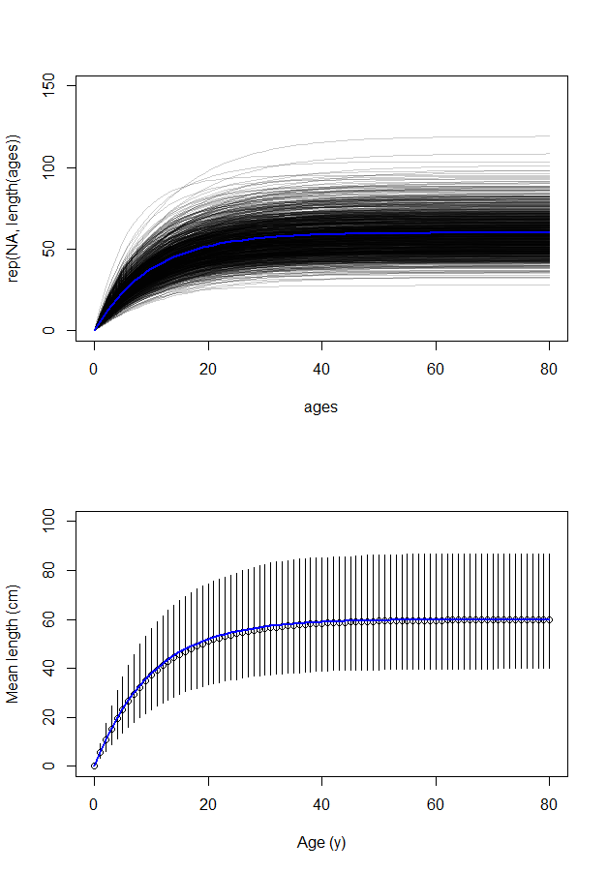

**Figure 2: Individual growth paths from 1000 *K* and *Linf* random draws (top graph). Blue line shows true vB curve for *K* = 0.1 and *Linf* = 60. Dots (bottom graph) are the boot-strap means vertical lines are bootstrap 95% confidence intervals.**

The log normal pattern was evident in the model generated length distributions by age (Figure 3).

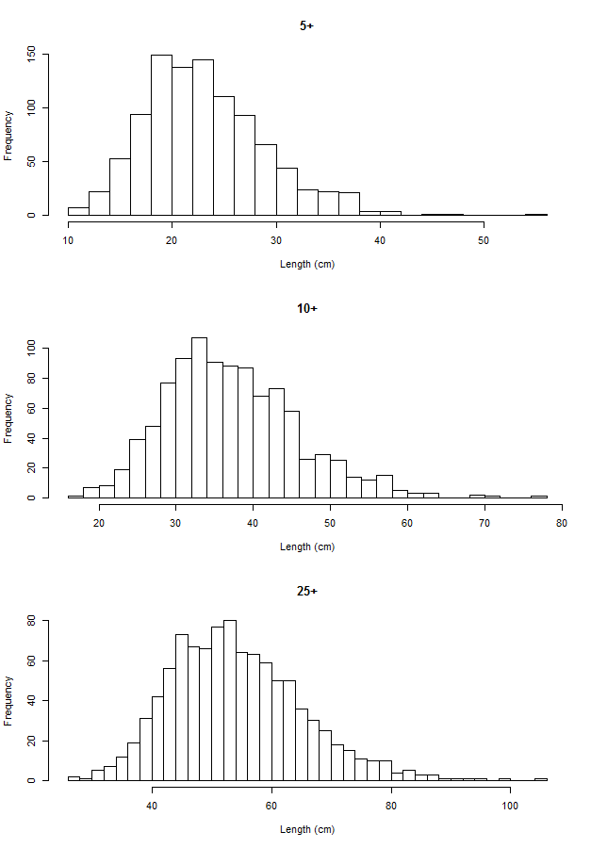

**Figure 3: Model length frequencies for ages 5, 10, and 25 as derived from the 1000 random vB growth paths**

## Casal model SSB estimates from “true” SNA 1 3 area IBM

### Model specifications

An IBM with similar spatial structure productivity dynamics and catch history to SNA 1 was constructed. The model comprised three stock areas comparable to East Northland (ENLD, Hauraki Gulf (HAGU), and Bay of Plenty (BPLE) but did not incorporate movement between stock areas. Four harvest methods specified in the model were: Bottom Long Line (BL); Bottom Trawl (BL), Danish Seine (DS) and recreational line (REC). The model covered the period 1900 to 2017 with similar method-area catch histories to those used in the 2013 SNA 1 assessment. The model stock area B0 values in tonnes were: ENLD 100,000; HAGU 200,000; BPLE: 100,000. The model was configured to allow variable individual growth but there was no variation on year class strength. The models main parameter values are given in Table 1. Gear selectivities were length-based and the same in all areas as was growth (Table 1).

**Table 1: IBM fixed parameters**

|  |  |  |
| --- | --- | --- |
| Natural mortality | *m* | 0.075 y-1 |
| Stock-recruit steepness (Beverton & Holt) | *h* | 0.85 |
| Proportion mature |  | 0 for ages 1–4, 0.5 for age 5, 1 for ages > 5 |
| Length-weight [mean weight (kg) = *a* (length (cm))b] |  | *a* = 4.467 × 10-8, *b* = 2.793 |
| von Bertalanffy growth parameters |  |  |
|  | *L∞* | 60.0 |
|  | *k* | 0.1 y-1 |
| Coefficient of variation on vB length at age | *cv* | 0.2 |
| Selectivity Long Line {Length based double normal} | *a, σL, σR* | 30.47, 2.76, 1000 |
| Selectivity Bottom Trawl {Length based double normal} | *a, σL, σR* | 29.39, 2.35, 29.15 |
| Selectivity Danish seine {Length based double normal} | *a, σL, σR* | 31.63, 3.13, 20.54 |
| Selectivity Rec {Length based double normal} | *a, σL, σR* | 30.11, 1.97, 15.27 |
| MLS |  | recreational 30 commercial 25 |

Observational data generated by the IBM as input to a similar configured casal model were:

* Three longline relative abundance indices (one for each area) covering the entire history of the model.
* Proportional catch at-age observations for all methods in all areas over the entire history of the model.

The casal estimator model was aged-based but otherwise structural identical to the IBM and configured with the same fixed parameters given in Table 1 with the exception of the selectivity parameterisations.

The casal model inputs were:

* Catch history
* IBM generated long line abundance indices
* IBM Catch at-age observations
* IBM multinomial error on catch at-age

Estimated in the Casal model were:

* B0 for each stock (3 parameters)
* Age-based selectivities for each method (double normal; 12 parameters)
* Catchability (qs) for the abundance indices (3 parameters)

### Model fits

The Casal model B0 estimates were very close to the “true” IBM values and casal likewise achieved very good predictive match to the IBM historical spawning stock biomass (SSB) trajectory (Table 2; Figure 4).

**Table 2: CASAL estimates of B0**

|  |  |  |
| --- | --- | --- |
|  | IBM B0 | CASAL estimate |
| East Northland | 100000 | 98984 |
| Hauraki Gulf | 200000 | 207605 |
| Bay of Plenty | 100000 | 99442 |

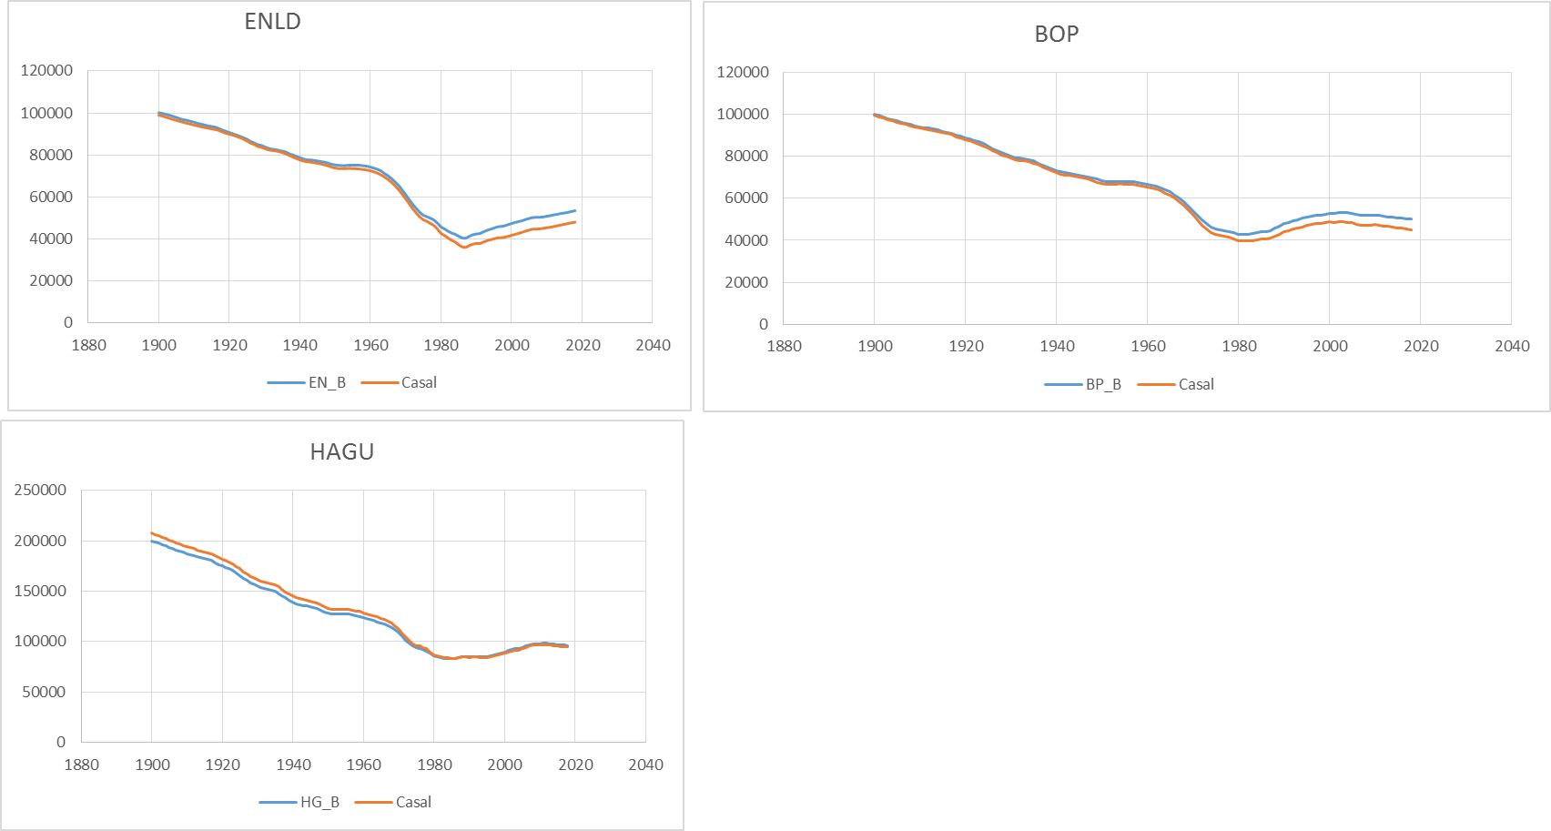

**Figure 4: Comparison of IBM and Casal spawning stock biomass trajectories for each SNA 1 simulated area**

Some possible reasons why the two model did not match more closely are:

* Casal selectivity is aged-based where-as the true process is length-based this may have resulted in less-than-perfect casal model predictions of catch at-age
* The order casal applies mortality in the annual time-step differs from the IBM sequence.
* There are significant computational differences in the way CASAL uses the vB curve to derive mean length at age (ergo biomass).

We intend to look further into the reasons for these slight differences however, the over-all result from the first preliminary test is very encouraging and we believe the IBM is basically performing well as measured against a modelling tool of known integrity, i.e. CASAL.

# References

Francis, R.I.C.C. (1988) Are growth parameters estimated from tagging and age-length data comparable?

*Canadian Journal of Fisheries and Aquatic Sciences* 45, 936 – 942

# APPENDICES

**Appendix 1: Model implementation of the VB growth increment model**

Uses a VB (linear increment) approach

*K* and *Linf* are generated as lognormal random deviates each fish *y* is assigned its own growth path as specified by *Ky*  and *Linfy*

Derivation of *K* ~ (lognormal) assumes K comes from a lognormal distribution with mean = *K* and variance = *v* = (*K*\*cv)2.

In log space log(k) come from a normal distribution with mean = 'u' and standard deviation 's' calculated as follows:

Likewise *log(Linf)~(Normal)*

The expected growth increment for a fish of length L with growth path *Ky* and *Linfy* over unit time t is given by the linear increment formulation of the vB (Francis 1988)



Where:

= change in length (increment) over unit time t for a fish of given length

m = rate of change of *L* (

c = increment for a fish of length = 0 the intercept of =

The change in length (i.e. increment) for a fish of length over is given by